J-LAS and Merged Data Product Tutorial
Cyndy Chandler, US JGOFS DMO
October 2001

J-LAS is the US JGOFS customized version of the Live Access Server (LAS) developed at NOAA/PMEL by Steve Hankin, Jon Callahan and Joe Sirott. As of October 2001, this software is still a pre Beta release.

To begin: start up an Internet browser (Netscape or Internet Explorer) and
open a file from Cyndy Chandler’s web page:
URL is http://usjgofs.whoi.edu/~chandler/J-LASclass.html

Select one of the links from the J-LASclass page.

Some J-LAS Hints

There are three distinct areas in the main J-LAS screen. The title bar across the top includes a server title in the center (US JGOFS Process Studies) and four link buttons to the right.



Help: generic LAS help Options: modify Ferret settings
Home: will go to US JGOFS Ferret: goes to Ferret Home

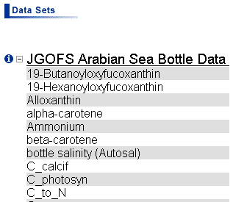Data sets are listed in the ‘left’ frame. Click on the name of a data set to expand it and view a list of available variables. Click on a variable name to select that variable within the expanded data set. The variable name should appear in the frame to the right. [Single variable only in this release.]

Select to display documentation window.

ie. Carbon to Nitrogen ratio; US JGOFS Arabian Sea Process Study Niskin samples

You can modify the data selection by adjusting spatial and temporal bounds:
Latitude, Longitude, Depth and Time ranges (XYZT respectively).

You may change the viewing plane. Select from: XY: Longitude v. Latitude
XZ: Longitude v. Depth (view from East)
YZ: Latitude v. Depth (view from South)

You may also wish to select a different product from the drop down list at the bottom of the screen. Current choices include a variety of GIF images and download formats:
XY pie plot (GIF) to get an indication of sample locations on lat/lon map
XZ pie plot (GIF) for longitudinal depth section
YZ pie plot (GIF) for latitudinal depth section
XZ [YZ] Gaussian filled plot (GIF); algorithm used is a Gaussian weighted mean of input points where weights vary with Gaussian decay and independent cutoff value.
It is also possible to download the data in plain text format or as a NetCDF file.

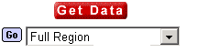When you have made desired adjustments to various ranges, choose Get Data to view your data (usually as a GIF image in a new window).

The next few pages are printed from the generic LAS Help screen. Try some things out, have fun, ask questions when you get stuck. I’m very interested in knowing what you like about the interface and any suggestions you might care to share. Please keep in mind you are using a pre-Beta release version.

cchandler@whoi.edu

