WOODS HOLE
OCEANOGRAPHIC INSTITUTION

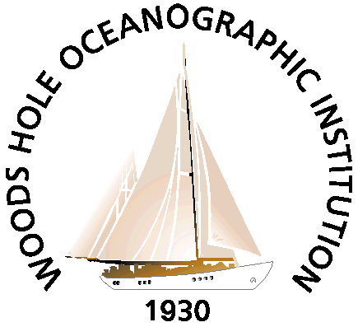

A GUIDE TO THE RECORDS OF THE

U.S. Joint Global Ocean Flux Study

Data Management Office,

1988 to 2005

Archival Collection ???

by

US JGOFS DMO and archivist

Archives of the Woods Hole Oceanographic Institution
MS-8, Woods Hole, MA 02543
December, 2006

A Guide to the Records of the

U.S. Joint Global Ocean Flux Study

Data Management Office,

1988 to 2005

Archival Collection ???
(??? lin. feet)

Processed by ???

Copyright:
Permission to publish material from the collection must be
authorized by the Institution Archivist.

Archives of the Woods Hole Oceanographic Institution
MS-8, Woods Hole, MA 02543
December, 2006

TABLE OF CONTENTS

HISTORICAL NOTE . . . . . . . . . . . . . . . . . . . . . . . . . . . . . . . . . . . . . . . . 1-3

SCOPE AND CONTENT NOTE . . . . . . . . . . . . . . . . . . . . . . . . . . . . . . . . 4

ORGANIZATIONAL CHART OF THE COLLECTION . . . . . . . . . . . . . . . . . 5-6
(INCLUDING RELATED COLLECTIONS)

SERIES DESCRIPTIONS/PROCESSING NOTES . . . . . . . . . . . . . . . . . . . . 7-16

CONTAINER LISTS . . . . . . . . . . . . . . . . . . . . . . . . . . . . . . . . . . . . . . . . 17- 59

Preferred Citation
Collection Name, Date. Collection Number, “Folder name.” Data Library and Archives, Woods Hole Oceanographic Institution.

HISTORICAL NOTE

Content from updated USJGOFS page complete with links …

Administrative History
Some story about the US JGOFS DMO … from paper?

SCOPE AND CONTENT NOTE

The U.S. Joint Global Ocean Flux Study Data Management Office (U.S. JGOFS DMO) collection consists of administrative, contractual, technical and scientific records of the DMO.

The collection includes material … topics of interest …

The U.S. JGOFS DMO collection includes material in many formats--correspondence, technical information, scientific data, public relations materials, and drafts of publications. It spans the period 1988-2005 ???. Because of the volume of information, the material was grouped in series under the following headings: NABE, EqPac, Arabian Sea and Southern Ocean. A provenance and processing note was added to each series description to clarify how each was accessioned and processed.

ORGANIZATIONAL CHART OF THE COLLECTION

ADMINISTRATION

Alvin Operations:
Master Files, 1961-1994
Chronological Files, 1958-1979
Miscellaneous Files, 1973-1985
Publications - WHOI Publications regarding Alvin, 1962-1975
Visitors Logs, 1962-1992

COMMITTEES AND POLICIES

Requests to Use Alvin, 1976-1994
UNOLS (University-National Oceanographic Laboratory System) Review Committee,
1975-1988

SCIENTIFIC DATA

Pre-Dive Checklists, 1966-July, 1987
Dive Data, Arranged by Dive Number, 1964-1998

ORGANIZATIONAL CHART OF THE COLLECTION

RELATED COLLECTIONS

WHOI ARCHIVES

Archives Vault:

Film Vault:

Records Storage

Main Reference Room

SERIES DESCRIPTIONS / PROCESSING NOTES

DATA MANAGEMENT OFFICE ADMINISTRATION

OFFICE OPERATIONS

Master Files

Boxes ??? ???

This series, which is in chronological order, consists of copies of …

Chronological Files
Boxes ??? ???

The first set of boxes in this series contains material about the …
The second set of boxes (box nums ???) spans the years ??? and contains
[ Materials include correspondence, memoranda, publications, lists, proposals, and cruise prospectus, assessments, synopses, and reports. Files retain their original chronological order. ]
Provenance: This material was received from Cyndy Chandler, U.S. JGOFS DMO
Processing Note:

Systems and Equipment
Boxes ??? ???

These files include information about the ???. It includes ???
Provenance: This material was received from Cyndy Chandler, U.S. JGOFS DMO
Processing Note: See above note.

MISCELLANEOUS FILES
Box ??? DATE ???

Provenance: This material was received from Cyndy Chandler, U.S. JGOFS DMO
Processing Note:

PUBLICATIONS
Box ??? date ???

Included are materials published by
Provenance: This material was received from Cyndy Chandler, U.S. JGOFS DMO
Processing:

SCIENTIFIC DATA

NABE
Boxes: ??? ???

Provenance: This material was received from Cyndy Chandler, U.S. JGOFS DMO Processing Note:

CONTAINER LISTS

Box Folder Folder Title

NABE: Original Data from Principal Investigators

4 33 Alvin, IDOE (International Decade of Oceanographic Exploration)
Activity, 1969-1970
5 1 Alvin, Telecons Conference Notes, 1969-1970
2 Ship Safety, 1969-1974
3 Alvin, ARPA (Advanced Research Project Agency) Preliminary

Etc.

